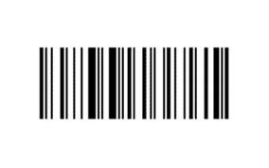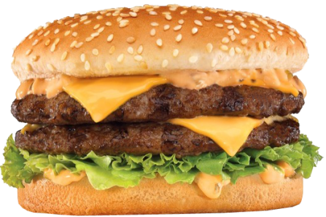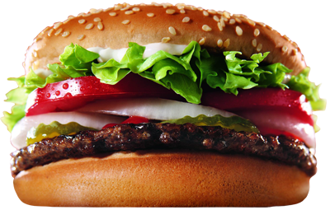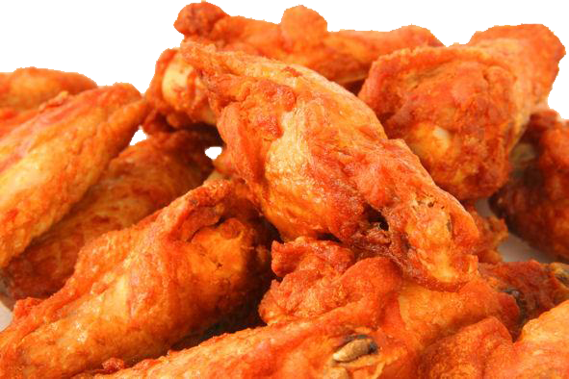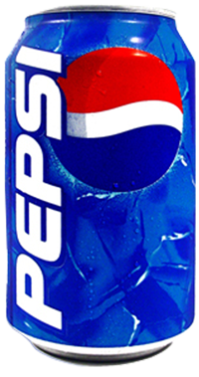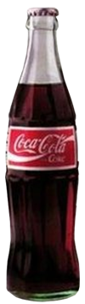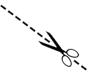

*1 Deal Free with 1*

No cash value. No cash Back. No rain checks, Coupon not valid on prior purchases, gift cards, licenses or event tickets. Offer good on in-stock merchandise only. You must present coupon at time of purchase to redeem. It cannot be combined with any other offer, coupon of employee or friends and family discount. Coupon may not be reproduced. You need to have one coupon per customer, per purchase. It excludes footwear, firearms and ammunition.

**Free Coupon Template**

*Treat Yourself*

**Restaurant Coupon Template**

*Treat Yourself*

No cash value. No cash Back. No rain checks, Coupon not valid on prior purchases, gift cards, licenses or event tickets. Offer good on in-stock merchandise only. You must present coupon at time of purchase to redeem. It cannot be combined with any other offer, coupon of employee or friends and family discount. Coupon may not be reproduced. You need to have one coupon per customer, per purchase. It excludes footwear, firearms and ammunition.

*1 Deal Free with 1*