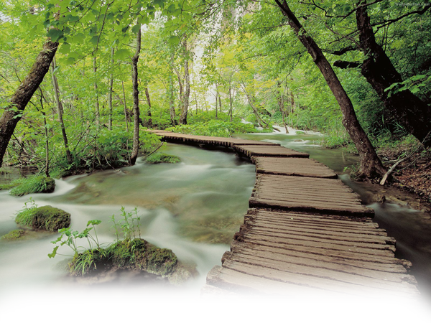

|  |  |  |  |
| --- | --- | --- | --- |
|  | | **Monday**  _________________________________________  __________________________________________  __________________________________________  _________________________________________  ___________________________________________  __________________________________________  _________________________________________ | |
| **Tuesday**  __________________________  __________________________  __________________________  __________________________  __________________________  __________________________  __________________________  ____________________________ | **Wednesday**  __________________________  __________________________  __________________________  __________________________  __________________________  __________________________  __________________________  ____________________________ | | **Thursday**  __________________________  __________________________  __________________________  __________________________  __________________________  __________________________  __________________________  ____________________________ |
| **Friday**  __________________________  __________________________  __________________________  __________________________  __________________________  __________________________  __________________________  ____________________________ | **Saturday**  __________________________  __________________________  __________________________  __________________________  __________________________  __________________________  __________________________  ____________________________ | | **Sunday**  __________________________  __________________________  __________________________  __________________________  __________________________  __________________________  __________________________  ____________________________ |

**Weekly Planner Template**

|  |  |  |  |  |  |  |
| --- | --- | --- | --- | --- | --- | --- |
| **June 2011** | | | | | | |
| **S** | **M** | **T** | **W** | **Th** | **F** | **S** |
|  |  |  | **1** | **2** | **3** | **4** |
| **5** | **6** | **5** | **7** | **9** | **10** | **11** |
| **12** | **13** | **14** | **15** | **16** | **17** | **18** |
| **19** | **20** | **21** | **22** | **23** | **24** | **25** |
| **26** | **27** | **28** | **29** | **30** |  |  |

**June 2011**

***What to Do this Week***