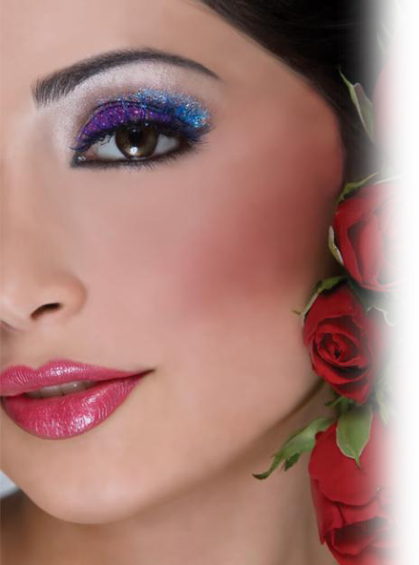

Timings:

**12:00 AM to 12:00 PM**

*Services Available for full Week*

**Salon Flyer**

Special Services Offered:

Nail Care ___________ $ 00.0

Hair Care___________ $ 00.0

Hair Styling _________ $ 00.0

Party Makeup________$00.0

Bridal Makeup _______$ 00.0

Spa Services _________$ 00.0

Manicure ___________$ 00.0

Pedicure ____________$ 00.0

Facial ______________ $ 00.0

Hair Cutting _________ $ 00.0

Contact At:

Phone: 555-555-12345674

Email Address: abc@example.com

Website: aftemplates.com

Address Line 1 Here

Address Line 2 Here

City, State, Zip Code

*Few lines about new offers few lines about new offers few lines about new offers*

*Beauty grooms here.....*

Salon Name Here

**Company Name**