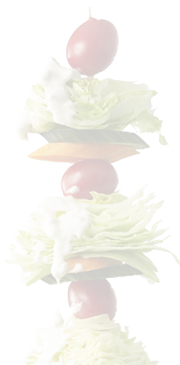

**Grocery Products:** _______________________________________________________________________________________________________ ____________________________________________________________________________________________________________________________

____________________________________________________________________________________________________________________________

|  |  |  |  |  |  |  |  |
| --- | --- | --- | --- | --- | --- | --- | --- |
|  | **Monday** | **Tuesday** | **Wednesday** | **Thursday** | **Friday** | **Saturday** | **Sunday** |
| **Breakfast** |  |  |  |  |  |  |  |
| Fruits & Vegetables |  |  |  |  |  |  |  |
| Grain Products if any…. |  |  |  |  |  |  |  |
| Milk, Juices & Alternatives |  |  |  |  |  |  |  |
| **Lunch** |  |  |  |  |  |  |  |
| Fruits & Vegetables |  |  |  |  |  |  |  |
| Grain Products if any…. |  |  |  |  |  |  |  |
| Milk, Juices & Alternatives |  |  |  |  |  |  |  |
| **Dinner** |  |  |  |  |  |  |  |
| Fruits & Vegetables |  |  |  |  |  |  |  |
| Grain Products if any…. |  |  |  |  |  |  |  |
| Milk, Juices & Alternatives |  |  |  |  |  |  |  |
| **Snacks** |  |  |  |  |  |  |  |
|  |  |  |  |  |  |  |  |
|  |  |  |  |  |  |  |  |

**Weekly Menu Planner for Moms**

*Weekly Menu Planner Menu for Planning Healthy Diet for Kids*

**Menu Planner Template**