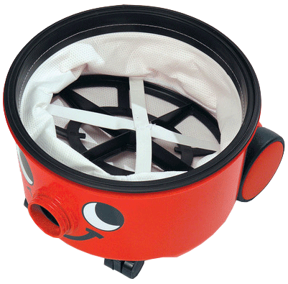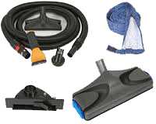

Step 1: ________________________________________________________________________________

Caution: ________________________________________________________________________________

Step 2: ________________________________________________________________________________

Caution: ________________________________________________________________________________

Step 3: ________________________________________________________________________________

Caution: ________________________________________________________________________________

***INSTALLATION***

*A guide to the installation, use and cleaning of* ***Machinery*** *with the help of User Manual. Read the instructions carefully and enjoy the best cleaning services of our brand. For further information and details, you may log on our website where all other necessary information is available. We have also facility of 24 hours helpline, where our staff is ready available for you.*

*A name of quality and reliance for customers*

**Machinery User Manual**

* Vacuum nozzle
* Hose
* Lo120ft long cord
* Dust bag
* Cleaning brushes
* Handheld tools

***ACCESSORIES***

***For more information contact us at:***

**Company Name Here**  
address line 1 address line 2  
phone: 555-555-55555  
fax: 555-555-55555  
www.emailaddress.com

***HOW TO USE***

1. Write here details of instructions to use vacuum cleaner Write here details of instructions to use vacuum cleaner Write here details of instructions to use vacuum cleaner
2. Write here details of instructions to use vacuum cleaner Write here details of instructions to use vacuum cleaner Write here details of instructions to use vacuum cleaner
3. Write here details of instructions to use vacuum cleaner Write here details of instructions to use vacuum cleaner
4. Write here details of instructions to use vacuum cleaner Write here details of instructions to use vacuum cleaner

***MAINTENANCE GUIDE***

1. Write here details of instructions to use vacuum cleaner Write here details of instructions to use vacuum cleaner Write here details of instructions to use vacuum cleaner
2. Write here details of instructions to use vacuum cleaner Write here details of instructions to use vacuum cleaner Write here details of instructions to use vacuum cleaner
3. Write here details of instructions to use vacuum cleaner Write here details of instructions to use vacuum cleaner
4. Write here details of instructions to use vacuum cleaner Write here details of instructions to use vacuum cleaner.